Assignment 1- Power BI Installation

**Report View page – when the Power BI Starts:**

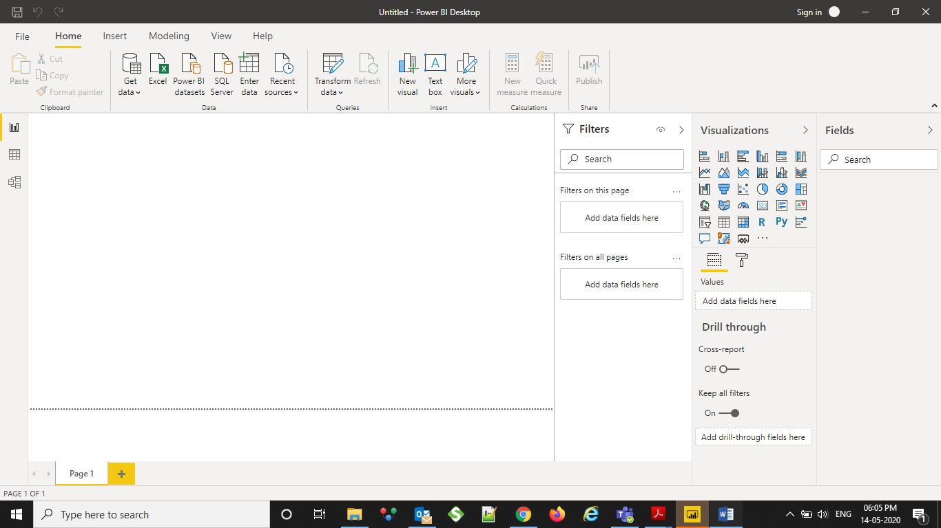

Report View:

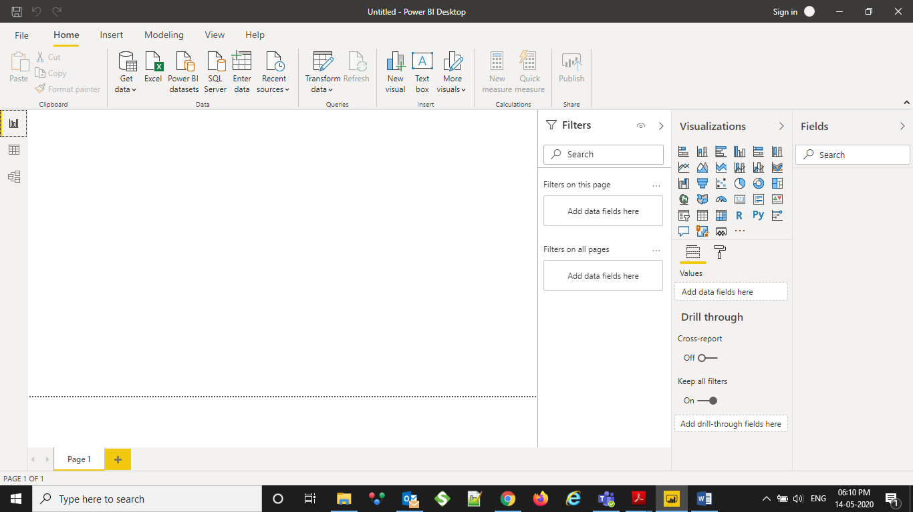

Data View

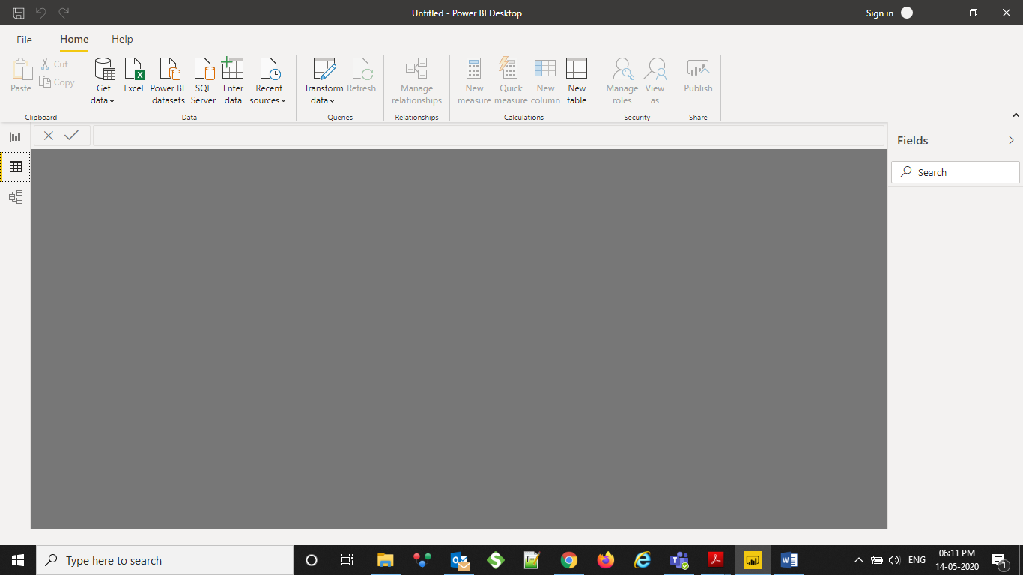

Model View

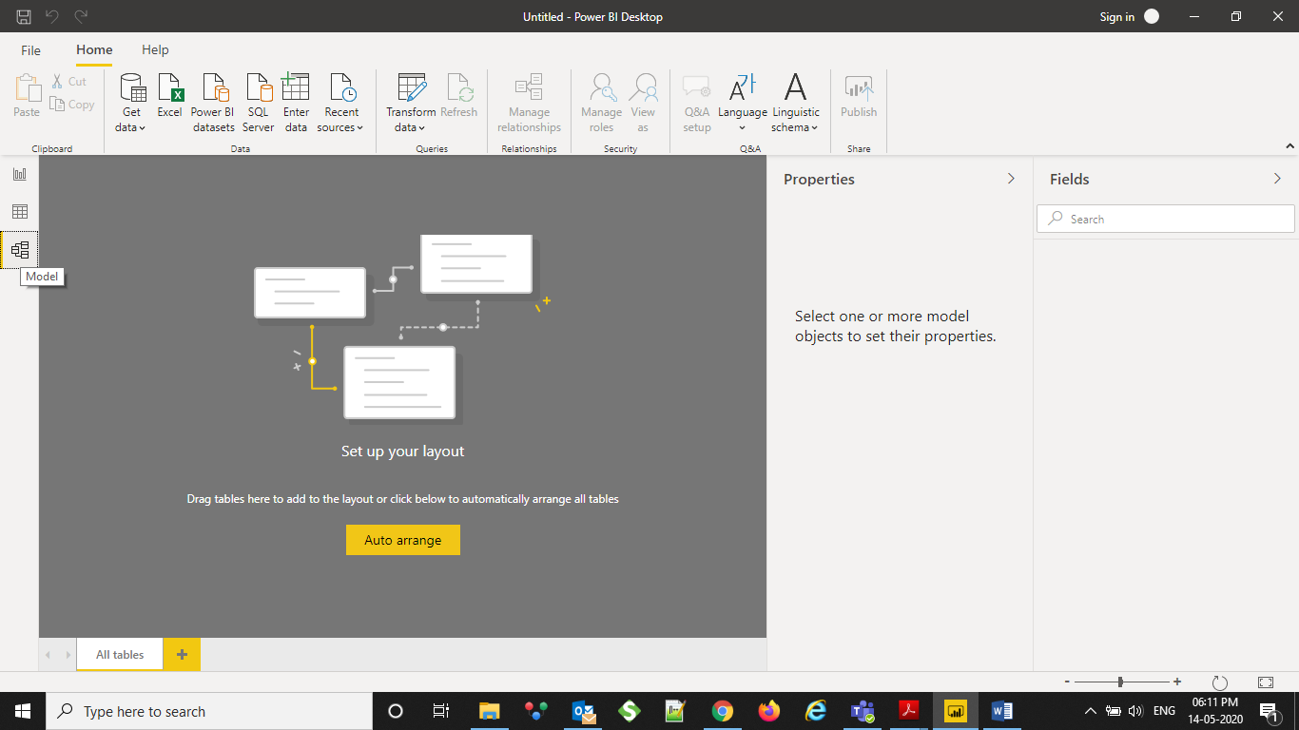

Power Query Editor:

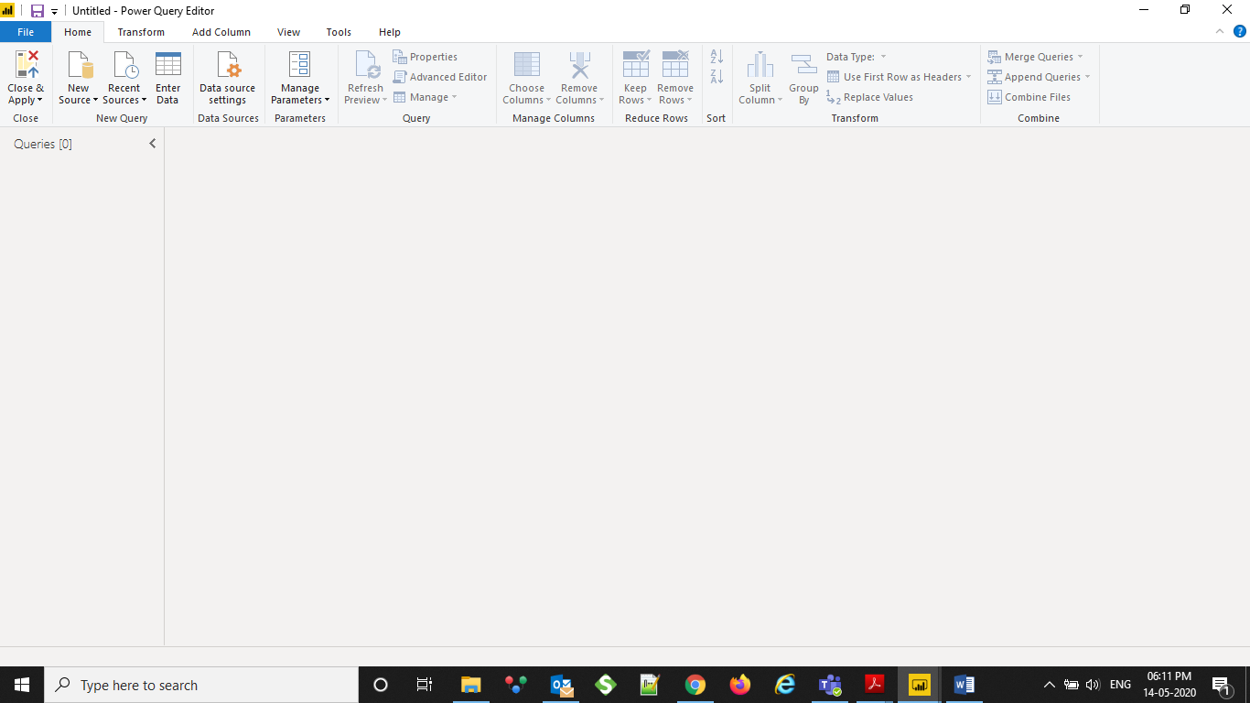

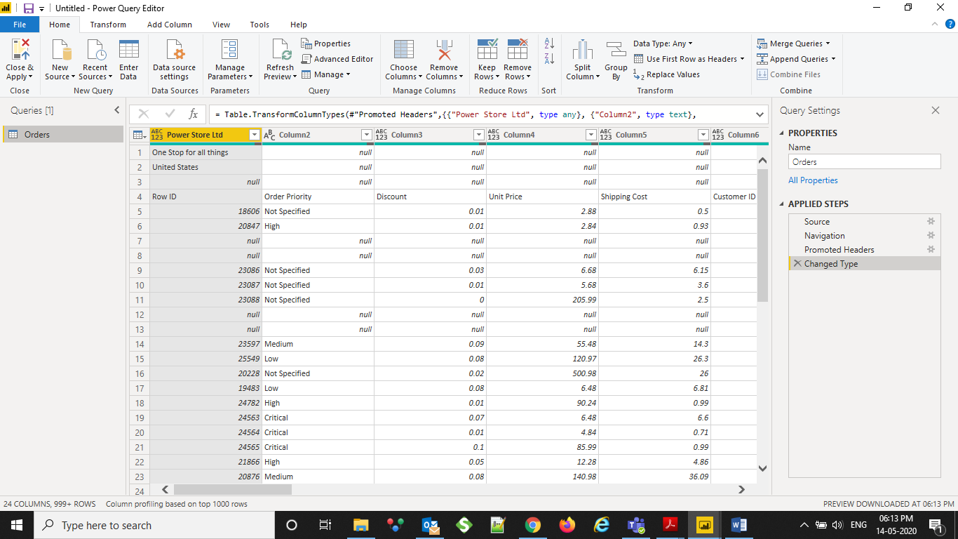

Advanced Editor:

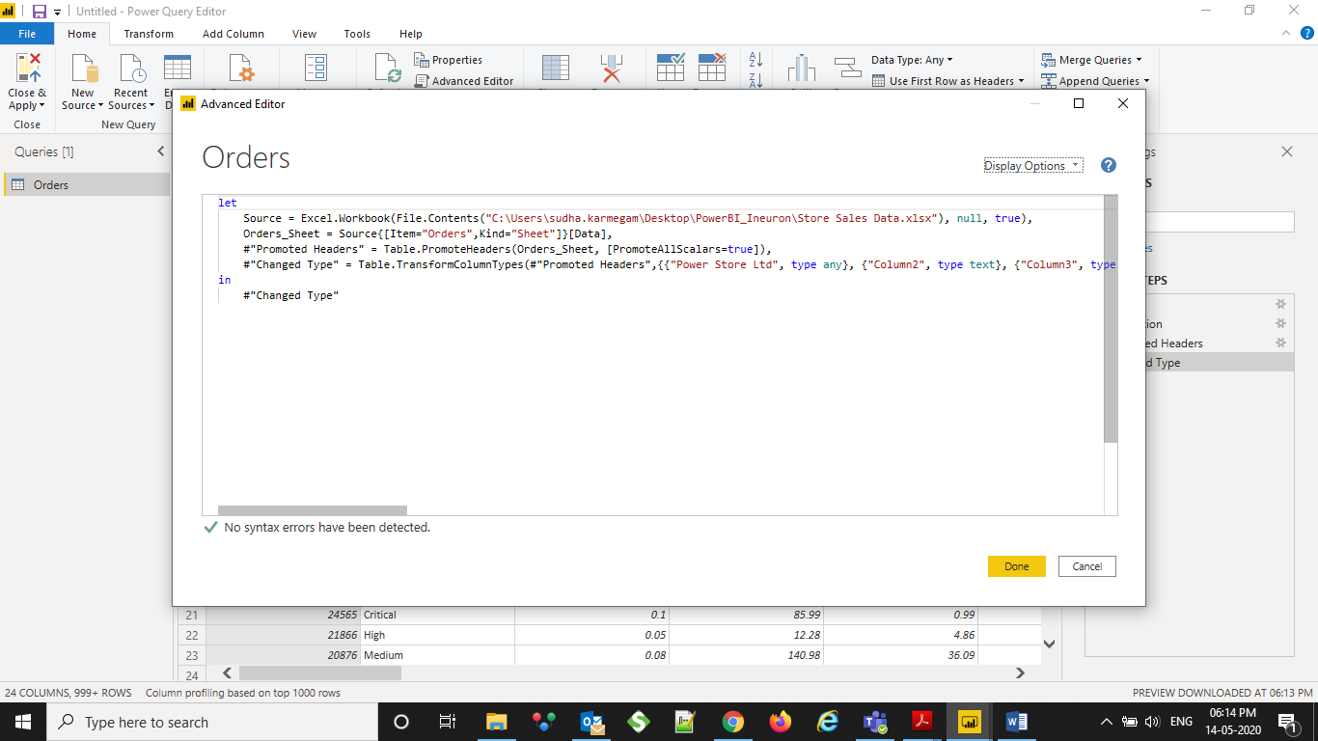

**3. Price**

Power BI Desktop – Free

Power BI Pro - $9.99 monthly per user

Power BI Premium: $4995 Monthly per dedicated cloud resource with annual subscription

